APPLICATION :

________________________________________

1) Testing: [automation] ---->selenium

2) Developing: 1) front end , 2) back end

3) Data analist: a person who collects previous data

4) Data scientist : a person who will predict the future by looking into previous data

5) Gaming development

6) ML(machine learning)

1)self driving cars

2)image recognization

7) Desktop application

8) Robotics

__________________________________________

HISTORY OF PYTHON :

__________________________________________

Developed : **guido van rossum**

implemented : 1989

released : 1991

Why 2 year gap ?

---->

He was in a research and he compared his programming language with other programming language

and he implement different inbuilt functions and methods.

Why is it python ?

---->

When he began implementing python guido van rossum was also reading the script which was published

by BBC comedy series the name of that script was

"monty python's flying circus"

van rossum tought he needed a name that was short and unique so he decided to call the language as PYTHON

________________________________________________________________________________

# **Features** #

1) Python is a very simple language

2) Readable syntax

3) easy to learn

4) it is free and open source

5) it supports cross platform

1) based on os : windows , linux , mac ,ubuntu

2) based on system : hp , Dell , acer etc

3) based on browser : chrome , firefox , opera , uc browser

6) it supports dynamic memory allocation

1) once we initialise the value , immediatly in the next line we can reassign the value

a = 10

print(a)

10

a ="bikash"

type(a)

<class 'string'>

b = [1,2,3]

type (b)

<class 'list'>

c = (1,2,3)

type(c)

<class 'tuple'>

d = {1,2,3}

type (d)

<class 'set'>

e = {"a":10 , "b":20}

type (e)

<class 'dict'>

7) it is a powerfull object oriented programming language :

1) class

2) objects

3) polymorphism

4) encapsulation

5) abstraction

6) inheritance

8) It is widely used for general purpose

1) all application

9) It is high level programming language

1) language : mode of communication

2) program : they are set of instruction given to machine to achive output

3) programing language : It is the communication happens between the human and the machine

4) low level lang : The language which is understand only machine is called as low level language

(because mahine understand only 0 and 1)

5) high level lang : the language which is understandable by human beings is called as high level language

10) It has large standard librabry :

Python has a rich inbuilt librabray

11) It is interpreter language :

1) compiler : convert high level lang to low level lang

2) interpreter : It convert low level language to high level language

during the execution it will check the program line by line

#Q Why python is called as only interpreter language?

----> In python compilation happens implicitly (internally) and in interpretation process happens xplicitly (externally)

so it is called interpretation language.

#Q Explan the compilation and interpretation process in python ?

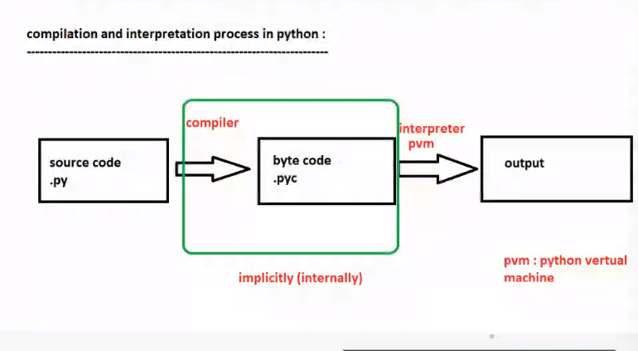

## IDENTIFIERS :--->

1)It isa user defined names to represent a variable , functions , class or any other object

2) If you assign some to a programmable entity ( structure / body ) it is nothing but an identifer

3) to check whether a python identifer is valid or not :

"string".isidentifier() ?

----> true